# STEPS TO SETUP XML/XSD PARSER

1. Install GIT (This repository was maintained using the version 2.25.1 on Windows10):

<https://git-scm.com/downloads>

1. Install Python (This application was built in the version 3.8.1):

<https://www.python.org/downloads/>

1. Download the GITHUB repository maintained for this application, into your local system (you need to have a github account which I’ve provided access to):

<https://github.com/vikrantdeshpande09876/XML_to_CSV_Rep>

1. Open Command Prompt (cmd) and navigate to the directory where you downloaded the above repository. For example:

*cd C:\Users\mypc\Desktop\XML_to_CSV*

1. Now create a virtual environment for creating a copy of your system-wide Python interpreter:

*python -m venv myvirtualenv*

1. Activate this virtual environment. You need not perform step#4 each time for execution:

*myvirtualenv\Scripts\activate*

1. Install flask:

*pip install flask*

1. Install the application-specific dependencies by executing:

*pip install -r requirements.txt*

1. Set the starting point for running this Flask application as *run.py:*

*set flask_app=run.py*

1. Execute the application:

*flask run*

1. Open a web-browser and navigate to the URL mentioned in the cmd output from above command. For example <http://127.0.0.1:5000/> which is the same as <http://localhost:5000/>

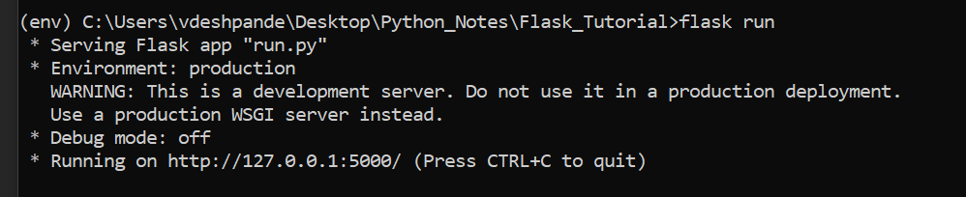

1. Currently the application accepts (username, password) from the excel file *Login_creds.xlsx* for logging in. This file is located in the /static/ folder of the application, for example:

*C:\Users\mypc\Desktop\XML_TO_CSV\static*